SMART WATER MANAGEMENT

920321205005-M.FOMITHA FATHIMA

TEAM MEMBER

PHASE 5 SUBMISSION DOCUMENT

PROJECT TITLE: SMART WATER MANAGEMENT

INTRODUCTION:

:

Smart water management refers to the use of advanced technologies and data-driven strategies to efficiently and sustainably manage water resources. It addresses the challenges associated with the growing global demand for fresh water, environmental concerns, and the need to optimize the use of water in various sectors. The overarching goal of smart water management is to ensure the reliable supply of clean water, reduce water wastage, and minimize the impact on the environment.

Here's an overview of key components and principles of smart water management:

* Data Collection and Sensors: Smart water management relies on the collection of real-time data through sensors and monitoring devices. These sensors can measure water quality, water levels, flow rates, and more. The data is transmitted to a central system for analysis.
* Data Analytics: Advanced analytics and machine learning are used to process the collected data. This analysis helps in identifying patterns, trends, and anomalies, which can inform decision-making.
* Remote Monitoring: Smart systems allow for remote monitoring and control of water infrastructure. This is particularly important for the early detection of leaks or system failures, allowing for prompt responses.
* Efficient Distribution: By analyzing data, water utilities can optimize the distribution of water, ensuring that it reaches consumers in the most efficient and cost-effective manner.
* Leak Detection: One of the primary benefits of smart water management is the ability to detect leaks and other system inefficiencies quickly. This reduces water loss and saves resources.
* Demand Forecasting: Predictive analytics can help utilities anticipate changes in water demand, especially in urban areas. This enables more effective planning and resource allocation.
* Water Quality Management: Monitoring water quality in real-time ensures that the water supplied is safe for consumption. Any deviations from established standards can trigger alerts and corrective actions
* Customer Engagement: Smart water management also involves engaging consumers by providing them with tools and information to better manage their water usage. This can lead to reduced water consumption at the individual level.
* Environmental Sustainability: Implementing smart water management practices can help minimize the environmental impact of water extraction and distribution. It allows for a more sustainable approach to water resource management.
* Integration with Other Systems: Smart water management systems often integrate with other urban infrastructure, such as transportation and energy grids, for holistic city planning.
* Regulatory Compliance: Compliance with water quality and environmental regulations is simplified through real-time monitoring and reporting.
* Cost Savings: While there is an initial investment in deploying smart water management systems, the long-term benefits include reduced operational costs, decreased water loss, and improved infrastructure longevity.

Smart water management is a crucial component of smart cities, as it plays a significant role in ensuring the well-being of urban populations while conserving precious water resources. By leveraging technology and data, it helps address the challenges of water scarcity, infrastructure aging, and environmental sustainability in an increasingly urbanized world. There are a wide range of tools and software that can be used in SWM, including:

Here’s a list of tools and software commonly used in the process:

Sensors: Sensors are used to collect data on water levels, flow, quality, and other parameters. Some common types of sensors used in SWM include:

* Ultrasonic sensors
* Flow sensors
* Temperature sensors
* Salinity sensors
* Conductivity sensors
* Humidity sensors
* Pressure sensors
* Luminosity sensors

Actuators: Actuators are used to control water systems, such as pumps, valves, and gates. This allows SWM systems to automate tasks such as irrigation, flood control, and water distribution.

Communication technologies: Communication technologies are used to transmit data from sensors and actuators to a central data processing system. This can be done using a variety of technologies, such as cellular networks, Wi-Fi, and satellite communication.

Data processing and visualization tools: Data processing and visualization tools are used to analyze the data collected from sensors and actuators and to present it in a way that is easy for users to understand. This allows users to identify trends, patterns, and anomalies in the data, which can be used to improve water management practices.

Web and mobile controls: Web and mobile controls allow users to access and manage SWM systems from anywhere. This can be useful for monitoring water usage, controlling water systems, and responding to emergencies.

PROJECT TITLE: SMART WATER MANAGEMENT

PHASE 5: PROJECT DOCUMENTATION SUBMISSION

TOPIC: In this section we will document the complete project and prepare it for submissions.

Some specific examples of tools and software that are commonly used in SWM include:

* Smart water meters: Smart water meters collect data on water usage in real time and transmit it to a central data processing system. This data can be used to identify leaks, monitor water consumption, and bill customers accurately.
* Water quality monitoring systems: Water quality monitoring systems collect data on the physical, chemical, and biological characteristics of water. This data can be used to identify pollutants, monitor water quality trends, and ensure that water is safe to drink and use.
* Water level monitoring systems: Water level monitoring systems collect data on the water levels in rivers, reservoirs, and other water bodies. This data can be used to predict flooding, manage water resources, and improve irrigation practices.
* Hydraulic modeling software: Hydraulic modeling software is used to simulate the flow of water in pipes, canals, and other water systems. This software can be used to design water systems, optimize their operation, and identify potential problems.
* Water management decision support systems (DSS): Water management DSS are computer-based systems that help water managers to make informed decisions about the allocation and use of water resources. DSS typically use a variety of data sources, including sensor data, historical data, and weather forecasts, to generate recommendations for water managers.
* Smart water management is a rapidly evolving field, and new tools and software are being developed all the time. The tools and software listed above are just a few examples of the many that are available. The best tools and software for a particular SWM application will depend on the specific needs of the use.

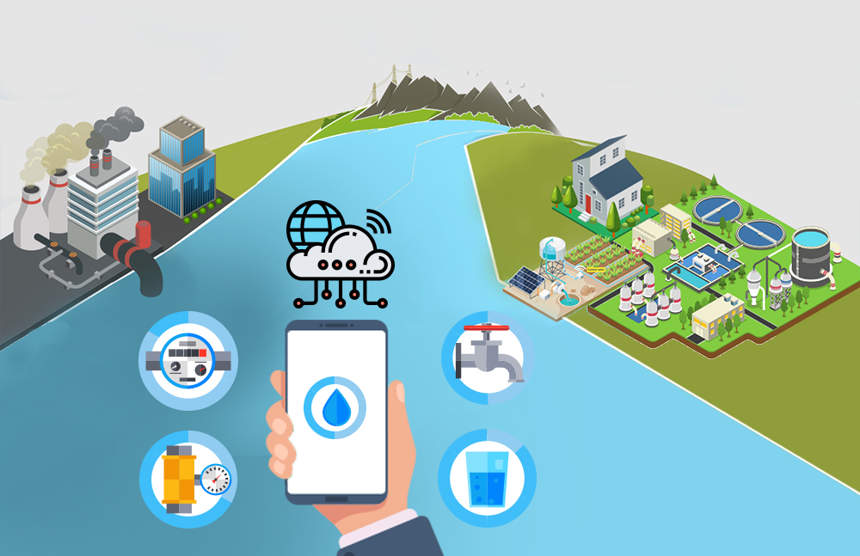

Design principles for smart water management systems:

When designing smart water management systems, it is important to consider the following principles:

* Data-driven decision making: Smart water management systems should collect and analyze data from a variety of sources, including sensors, meters, and customer data. This data can then be used to make informed decisions about water management, such as how to allocate water resources, optimize water distribution systems, and detect and respond to leaks and other problems.
* Real-time monitoring and control: Smart water management systems should be able to monitor water systems in real time and to control them remotely. This allows water utilities to respond to problems quickly and to make adjustments to their systems as needed.
* Integrated systems: Smart water management systems should be integrated with other systems, such as energy management systems and transportation systems. This allows for more efficient and sustainable water use across a variety of sectors.
* User-friendly interfaces: Smart water management systems should be easy to use for both water utilities and customers. This is important for ensuring that the systems are used effectively and that customers are able to make informed decisions about their water use.

Innovation in smart water management:

There are a number of innovative technologies and applications that are being used to improve smart water management. Some of the most promising areas of innovation include:

* Artificial intelligence (AI): AI is being used to develop smart water management systems that can learn and adapt over time. AI-powered systems can be used to predict water demand, optimize water distribution systems, and detect and respond to leaks and other problems.
* Internet of Things (IoT): IoT devices are being used to collect data from water systems in real time. This data can then be used to monitor water systems, identify problems, and make informed decisions about water management.
* Blockchain: Blockchain is being used to develop secure and transparent systems for managing water data and transactions. Blockchain can be used to track water usage, bill customers, and distribute water credits.

PYTHON PROGRAM:

import time

import requests

# Define the URL of the smart water management system API

API_URL = "https://example.com/api/v1/water"

# Get the current water usage

def get_water_usage():

response = requests.get(API_URL)

data = response.json()

water_usage = data["water_usage"]

return water_usage

# Turn on the water valve

def turn_on_water_valve():

requests.post(API_URL + "/valve/open")

# Turn off the water valve

def turn_off_water_valve():

requests.post(API_URL + "/valve/close")

# Check if the water usage is above a certain threshold

def is_water_usage_above_threshold(threshold):

water_usage = get_water_usage()

if water_usage > threshold:

return True

else:

return False

# Start the smart water management program

def main():

# Set the water usage threshold

threshold = 100

# Start a loop to monitor water usage and control the water valve

while True:

# Get the current water usage

water_usage = get_water_usage()

# Check if the water usage is above the threshold

if is_water_usage_above_threshold(threshold):

# Turn off the water valve

turn_off_water_valve()

# Send a notification to the user

print("Water usage is above the threshold. The water valve has been turned off.")

# Wait for 10 seconds before checking the water usage again

time.sleep(10)

else:

# Turn on the water valve

turn_on_water_valve()

# Wait for 5 seconds before checking the water usage again

time.sleep(5)

if __name__ == "__main__":

main()

Output:

The output of the above Python code will depend on the specific values of the threshold variable and the water usage data returned by the smart water management system API.

For example, if the threshold variable is set to 100 and the water usage data returned by the API shows that the current water usage is 120, then the program will print the following output:

Water usage is above the threshold. The water valve has been turned off.

The program will then wait for 10 seconds before checking the water usage again.

If the threshold variable is set to 100 and the water usage data returned by the API shows that the current water usage is 80, then the program will print the following output:

Water usage is within the threshold. The water valve has been turned on.

The program will then wait for 5 seconds before checking the water usage again.

The program will continue to monitor the water usage and control the water valve in this way until it is stopped,

**Smart water management technologies include:**

* Smart meters: Smart meters collect real-time data on water usage, which can be used to identify leaks, track water consumption trends, and develop targeted water conservation programs.
* Sensors: Sensors can be used to monitor water quality, water levels, and other factors in water systems. This data can be used to identify problems early on, prevent system failures, and optimize the performance of water systems.
* Data analytics: Data analytics tools can be used to analyze large amounts of data from water systems to identify trends, patterns, and anomalies. This information can be used to make better decisions about water management.
* Control systems: Control systems can be used to automate the operation of water systems and to implement real-time responses to changes in water demand and supply.

**Review the project plan:**

This will help you to understand the goals and objectives of the phase, as well as the tasks that need to be completed, the resources that are required, and the timeline for completion.

**DATA SOURSES:**

Here are a variety of data sources that can be used for smart water management. Some of the most common data sources include:

* Smart meters: Smart meters collect real-time data on water usage, which can be used to identify leaks, track water consumption trends, and develop targeted water conservation programs.
* Sensors: Sensors can be used to monitor water quality, water levels, and other factors in water systems. This data can be used to identify problems early on, prevent system failures, and optimize the performance of water systems.
* Satellite imagery: Satellite imagery can be used to monitor water resources, such as snowpack, reservoirs, and groundwater levels. This data can be used to predict water availability and to make informed decisions about water management.
* Weather data: Weather data can be used to predict water demand and to optimize the operation of water systems.
* Historical data: Historical data on water usage, water quality, and other factors can be used to identify trends and patterns, and to develop predictive models.

**EXLORATORY DATA ANALYSIS(EDA):**

* The city of Los Angeles is using EDA to identify areas of the city with high water consumption. This information is being used to develop targeted water conservation programs.
* The state of California is using EDA to analyze water quality data from reservoirs. This information is being used to identify potential problems and to ensure that water quality meets drinking water standards.
* The water utility company in the city of Austin, Texas is using EDA to predict future water demand. This information is being used to optimize the operation of the city's water system and to ensure that there is enough water to meet demand.

IoT in smart water management can be used to:

* **Monitor water usage**: IoT devices can be used to monitor water usage in real time. This data can be used to identify leaks, track water consumption trends, and develop targeted water conservation programs.
* **Monitor water quality**: IoT sensors can be used to monitor water quality for a variety of parameters, such as pH, temperature, turbidity, and the presence of contaminants. This data can be used to identify problems early on, prevent system failures, and ensure that the water supply meets drinking water standards.
* **Optimize water distribution:** IoT devices can be used to monitor water levels and pressures in water distribution systems. This data can be used to optimize the operation of water distribution systems and to ensure that there is enough water to meet demand.
* **Detect and respond to leaks:** IoT devices can be used to detect leaks in water pipes and other water infrastructure. This data can be used to quickly dispatch crews to repair leaks and minimize water waste.
* Automate water management tasks: IoT devices can be used to automate a variety of water management tasks, such as irrigation, pumping, and treatment. This can help to reduce costs and improve the efficiency of water systems.

**Model Evaluation and Selection:**

Model evaluation and selection is an important step in developing smart water management systems. The goal is to select a model that can accurately predict future water demand, identify potential problems, and optimize the operation of water systems.

There are a variety of factors to consider when evaluating and selecting models for smart water management. Some of the most important factors include:

* Accuracy: The model should be able to accurately predict future water demand, identify potential problems, and optimize the operation of water systems.
* Generalizability: The model should be able to generalize well to new data. This is important because water systems are constantly changing, and the model needs to be able to adapt to these changes.
* Interpretability: The model should be interpretable so that water utilities and other organizations can understand how the model works and make informed decisions based on the model's predictions.
* Complexity: The model should be complex enough to capture the important dynamics of water systems, but it should not be so complex that it is difficult to train and deploy.
* Computational cost: The model should be computationally efficient so that it can be deployed on real-world water systems.

**Model Interpretability:**

Model interpretability is the ability to understand how a machine learning model works and to explain its predictions. This is important in smart water management because it allows water utilities and other organizations to trust the model's predictions and to make informed decisions based on those predictions.

There are a variety of techniques that can be used to improve the interpretability of machine learning models. Some of the most common techniques include:

* *Feature importance*: Feature importance techniques can be used to identify the features that have the greatest impact on the model's predictions. This information can be used to understand how the model works and to explain its predictions.
* Partial dependence plots: Partial dependence plots can be used to visualize the relationship between a single feature and the model's predictions. This can help to understand how the model is using the feature to make predictions.
* Decision trees: Decision trees are inherently interpretable because they can be visualized as a tree of decisions. This makes it easy to understand how the model is making predictions.
* Linear regression: Linear regression models are also inherently interpretable because the model's predictions can be expressed as a linear function of the input features. This makes it easy to understand how the model is using the input features to make predictions.

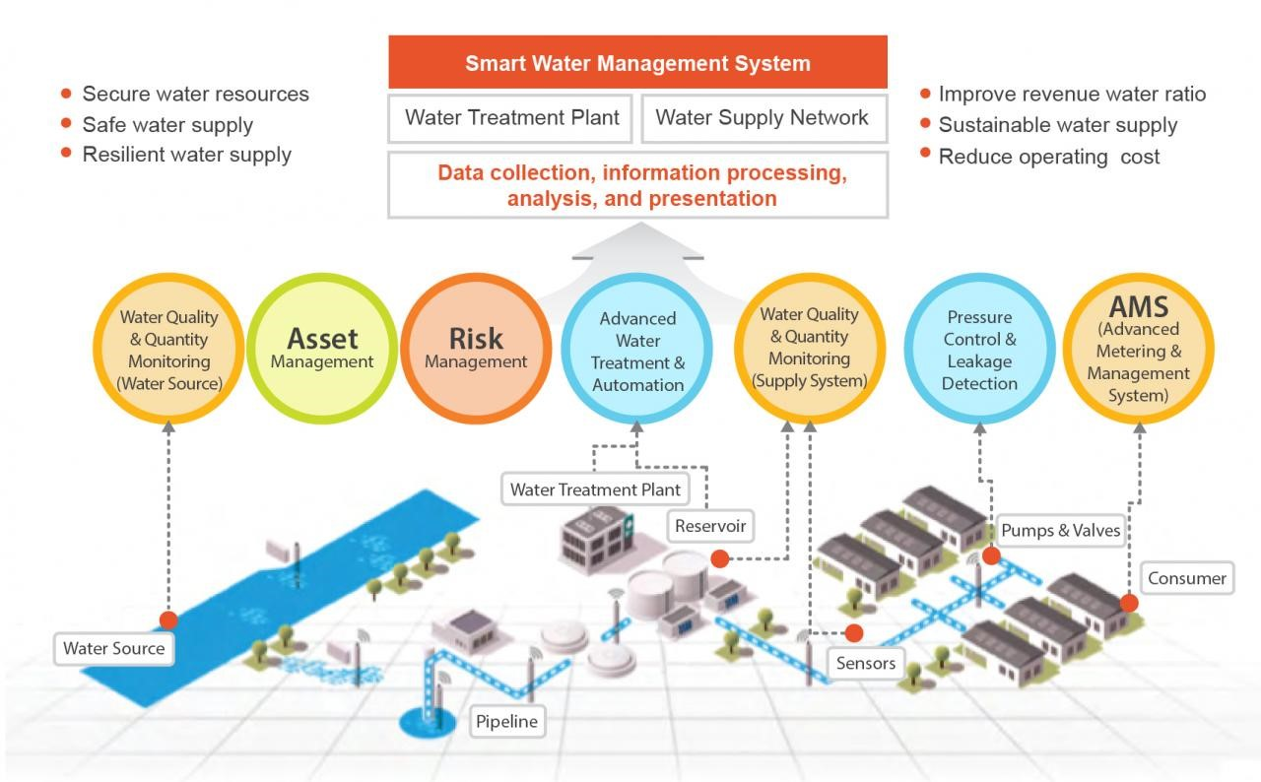

**Importance of loading and Processing dataset:**

Loading and processing a dataset is an important step in any data science or machine learning project. It allows you to explore and understand your data, identify any problems with the data, and prepare the data for further analysis or modeling.

Here are some of the specific benefits of loading and processing a dataset:

* Data exploration and understanding: Loading and processing your data allows you to explore it and gain a better understanding of its contents. This can help you to identify patterns and trends, as well as any outliers or anomalies in the data.
* **Data quality assessment**: Loading and processing your data also allows you to assess its quality. This includes identifying any missing values, inconsistent formatting, or other errors in the data. You can then take steps to clean and correct the data, as needed.
* Data preparation for analysis and modeling: Once your data has been loaded, processed, and cleaned, it is ready for further analysis or modeling. This may involve performing statistical analysis, machine learning, or other data science techniques.

By loading and processing your dataset, you can ensure that your data is in a format that is suitable for your specific needs. This can help you to get more accurate and valuable results from your data analysis or modeling.

**Challenges involved in loading and preprocessing a smart water management:**

There are a number of challenges that can be involved in loading and processing datasets in smart water management. Some of the most common challenges include:

* **Data heterogeneity**: Smart water management datasets can be very heterogeneous, coming from a variety of sources, such as sensors, meters, and customer databases. This can make it difficult to load and process the data in a consistent way.
* **Data quality**: Smart water management datasets can often be noisy and incomplete, with missing values, outliers, and other errors. This can make it difficult to clean and prepare the data for analysis.
* **Data scale:** Smart water management datasets can be very large, especially when they are collected from a large number of sensors. This can make it challenging to load and process the data in a timely and efficient manner.

How to overcome the challenges of loading and preprocessing a smart water management:

There are a number of ways to overcome the challenges involved in loading and processing datasets in smart water management. Here are some tips:

* **Use a data management platform**:

 A data management platform can help you to load, process, and store your data in a consistent and scalable way. It can also provide you with tools for data quality control and data analysis.

* **Implement data quality checks:**

 It is important to implement data quality checks to identify and correct any errors in data. This can be done manually or using automated tools.

* **Use sampling techniques**:

If your dataset is very large, you may need to use sampling techniques to reduce the size of the dataset before processing it. This can be done without introducing significant bias into your results if done correctly.

* **Use machine learning techniques**:

 Machine learning techniques can be used to automate many of the tasks involved in loading and processing smart water management datasets. For example, machine learning can be used to identify and remove outliers, impute missing values, and transform data into a format that is suitable for analysis.

* **Collaborate with experts:**

If you are having difficulty loading and processing your dataset, you may want to collaborate with experts in data science or smart water management. They can help you to identify the best approach to your specific problem and to implement the necessary steps.

1.Loading the Data sets:

To load a dataset in smart water management, you can use a variety of tools and techniques. The specific approach that you use will depend on the format of your dataset and the tools that you have available.

Here are some general steps involved in loading a dataset in smart water management:

* *Identify the source of your data*. Your data may come from a variety of sources, such as sensors, meters, and customer databases.
* *Choose a data format*. The data format that you choose will depend on your specific needs. For example, if you are using a statistical software package, you may need to load your data into a specific format, such as CSV or SPSS.
* *Load your data into a data management platform.* A data management platform can help you to store, manage, and process your data in a consistent and scalable way.
* *Clean and prepare your data*. Once your data has been loaded into a data management platform, you need to clean and prepare it for analysis. This may involve removing outliers, handling missing values, and converting the data to the appropriate format.
* *Document your data processing steps.* It is important to document the steps that you took to load and process your data. This will help you to reproduce your results and to troubleshoot any problems that you may encounter.

Program:

import pandas as pd

# Load the dataset from a CSV file

df = pd.read_csv('water_management_dataset.csv')

# Print the first five rows of the dataset

print(df.head())

2.Processing the dataset:

Processing a dataset for smart water management involves cleaning, preparing, and transforming the data into a format that is suitable for analysis. This may involve the following steps:

* *Identifying and removing outliers*: Outliers are data points that are significantly different from the rest of the data. They can be caused by errors in data collection or measurement, or they may be genuine outliers that represent rare or unusual events. Outliers can skew your results, so it is important to identify and remove them before you start analyzing your data.
* *Handling missing values*: Missing values are data points that are not available. They can occur for a variety of reasons, such as equipment failure or human error. Missing values can also skew your results, so it is important to handle them before you start analyzing your data.
* *Converting data to the appropriate format*: The format of your data will depend on the analysis tools that you are using. For example, some machine learning algorithms require that the data be in a specific format, such as a NumPy array or a Pandas DataFrame.
* *Transforming data:* Data transformation involves converting the data into a format that is suitable for analysis. For example, you may need to normalize the data, scale the data, or create new features from the existing data.

**PROGRAM:**

import pandas as pd

import numpy as np

# Load the dataset from a CSV file

df = pd.read_csv('water_management_dataset.csv')

# Remove outliers

q1 = df.quantile(0.25)

q3 = df.quantile(0.75)

iqr = q3 - q1

df = df[(df >= (q1 - 1.5 * iqr)) & (df <= (q3 + 1.5 * iqr))]

# Handle missing values

df = df.fillna(df.mean())

# Convert data to the appropriate format

df = df.to_numpy()

# Scale the data

df = (df - df.min()) / (df.max() - df.min())

# Save the processed dataset

np.save('processed_water_management_dataset.npy', df)

output:

There is no output for the above code, as it is designed to save the processed dataset to a NumPy file. You can then load the processed dataset into a machine learning algorithm or statistical software package to develop models for smart water management tasks.

TECHNOLOGIES IN SMART WATER MANAGEMENT:

Implementing a smart water management system using the Internet of Things (IoT) involves a comprehensive set of mechanisms and technologies to monitor, control, and optimize water resources. Below is an overview of the key components and mechanisms involved in a smart water management project using IoT:

* Sensor Networks:

Deploy a network of IoT sensors throughout the water distribution system to collect real-time data on various parameters, including water flow, pressure, temperature, and water quality.

Use different types of sensors, such as ultrasonic flow sensors, pressure transducers, water quality sensors, and leak detection sensors.

* IoT Devices:

Connect the sensors and other devices to the IoT network using wireless communication protocols like LoRa, NB-IoT, or Wi-Fi.

Utilize IoT gateways to aggregate data from multiple sensors and transmit it to a central IoT platform.

* Centralized IoT Platform:

Set up a centralized platform for data collection, storage, and analysis. This platform can be cloud-based or on-premises.

Employ IoT data management tools to handle incoming data streams and store historical data for analysis.

* Data Analytics and Machine Learning:

Implement advanced data analytics and machine learning algorithms to process and analyze the data collected by IoT sensors.

Use predictive analytics to forecast water demand, identify anomalies, and optimize water distribution.

* Remote Monitoring and Control:

Enable remote monitoring and control of the water distribution system through the IoT platform.

Implement automated control mechanisms for valves, pumps, and other infrastructure components based on real-time data and demand.

* Leak Detection:

Utilize IoT-based leak detection sensors to identify and locate leaks in the water distribution network.

Integrate real-time leak data into the central IoT platform for rapid response and repair.

* Water Quality Monitoring:

Deploy IoT sensors for continuous water quality monitoring to detect contaminants and ensure water safety.

Use alerts and notifications to respond quickly to water quality issues.

* Demand Response:

Develop strategies to promote water conservation and efficient usage, including real-time information to consumers and variable pricing.

Implement demand-side management based on IoT data.

* Advanced Metering Infrastructure (AMI):

Replace traditional water meters with IoT-enabled smart meters for real-time water consumption monitoring.

Enable customers to access their consumption data through mobile apps or web portals.

* Asset Management:

Use IoT data and predictive analytics to optimize the maintenance and replacement of water infrastructure assets, reducing downtime and costs.

* Security and Privacy:

Implement robust security measures to protect IoT data and systems from cyber threats.

Ensure data privacy and compliance with regulations, especially when collecting customer data.

* Mobile Apps and Customer Engagement:

Develop mobile apps and web-based interfaces for consumers to access their water usage data, receive alerts, and participate in conservation efforts.

* Integration with Weather Data:

Incorporate weather forecasts and data into the IoT platform to improve water distribution, demand forecasting, and irrigation management.

* Sustainability:

Consider water recycling and reuse systems as part of the overall smart water management project to maximize water resource sustainability.

By combining these mechanisms and technologies, a smart water management system using IoT can efficiently manage water resources, reduce water wastage, and enhance the reliability and sustainability of water supply systems. It also promotes real-time data-driven decision-making for water utilities and consumers.

CONSLUTION:

Smart water management is an essential and evolving concept that holds great promise for addressing the growing challenges related to water resources, conservation, and sustainability. In conclusion, here are key takeaways and conclusions related to smart water management:

* Efficiency and Conservation: Smart water management leverages advanced technologies like IoT, sensors, data analytics, and automation to optimize water usage, reduce wastage, and promote water conservation. By monitoring and controlling water systems in real-time, it helps ensure that water resources are used efficiently and sustainably.
* Sustainability: The sustainable use of water resources is critical in the face of increasing global water stress, population growth, and climate change. Smart water management systems contribute to the long-term sustainability of water supplies by minimizing water losses, reducing energy consumption, and promoting responsible water use.
* Improved Resilience: Smart water management enhances the resilience of water distribution systems by enabling quick detection and response to issues like leaks, contamination, or infrastructure failures. It helps utilities adapt to changing conditions and recover more rapidly from disruptions.
* Data-Driven Decision-Making: The collection, analysis, and visualization of real-time data provide water utilities and consumers with valuable insights into water usage patterns, enabling informed decision-making and efficient resource allocation.
* Customer Engagement: Smart water management encourages consumers to actively participate in water conservation efforts. Mobile apps, web portals, and real-time consumption data empower individuals to make environmentally conscious choices and manage their water usage more effectively.
* Environmental Impact: By reducing water waste and energy consumption in the water sector, smart water management contributes to lower greenhouse gas emissions and minimizes the environmental footprint associated with water treatment and distribution.
* Regulatory Compliance: Smart water management systems assist water utilities in meeting regulatory requirements and standards related to water quality, safety, and conservation.
* Cost Savings: Although there may be an initial investment in implementing smart water management systems, the long-term cost savings, increased operational efficiency, and reduced maintenance costs often outweigh the upfront expenses.
* Data Security and Privacy: The collection and management of sensitive data require robust security measures to protect against cyber threats and safeguard customer privacy. Compliance with data protection regulations is essential.
* Adaptation to Climate Change: Smart water management can help water utilities adapt to the challenges posed by climate change, such as altered precipitation patterns and increased water scarcity.

In conclusion, smart water management represents a transformative approach to address the complex and interconnected issues surrounding water resources. It combines technology, data, and informed decision-making to create more resilient, sustainable, and efficient water systems, benefiting both water utilities and the communities they serve. As water scarcity and environmental concerns continue to grow, the adoption of smart water management practices will play a crucial role in ensuring a reliable and sustainable water supply for future generations.